Program Management Plan
Digital Transformation Program

Name: Jogi Nijjar, Program Manager
Project Management Office
Date: January 13th, 2020
Version: 01.00

Contents
1.0 Program Purpose and Governance 3
2.0 Scope Management Plan 3
3.0 Decision Management Plan 4
4.0 Schedule Management Plan 4
5.0 Action and Issue Management Plan 4
6.0 Risk Management Plan 4
7.0 Cost Management Plan 5
8.0 Resource Management Plan 5
9.0 Communications Management Plan 5
10.0 Program Stakeholder Management Plan 5
11.0 Program Quality Plan 6
12.0 Program Change Control Plan 6
13.0 Approval Management Process 6

Program Purpose and Governance
The objective of this Program Management Plan is to document the approach used by the program team to deliver and communicate the intended scope of the Program, as approved in the Program Charter in regard to the expected benefits, deliverables, milestones schedule, risks, budget, and resource requirements.

The program will follow the Project Management Office methodology and the CWB Integrated Project Delivery Lifecycle (PDLC) throughout the life of the project. This establishes an effective governance framework which is critical to programs and projects, particularly if a program or project carries a significant amount of risk, has substantial costs and will span a lengthy period of time. It has a direct correlation with the Program's potential for long-term success because governance enables the program work, addressing such needs as:
- Continuous linkage to enterprise business strategy and direction.
- Clear and well-understood decision-making authority and accountability.
- Effective oversight of and insight into Program progress and direction.
- Executive control over Program evolution and outcomes.

The concept of governance has multiple dimensions and must include frameworks for:
- Scope management
- Risk management
- Resource management
- Communications
- Quality management

Exceptions to this plan, if any, will be added to the Program Charter as required and will be reviewed and approved by the Program Owners, the AVP, Program Management, and the Sr. Manager, PMO.

Scope Management Plan
The scope for this Program is defined by the Program Charter. The Program Manager, Program Owners, and Stakeholders will establish and approve documentation for measuring program scope.

Proposed scope changes may be initiated by the Program Manager, Project Manager, Stakeholders or any member of the program team. All change requests will be submitted to the Program Manager (or Project Manager if applicable) and will then be managed as outlined in the Program Change Control Plan.

The Program Owners are responsible for formally accepting the Program’s final deliverable(s). This acceptance will be based on a review of all program documentation, testing results, and completion of all tasks/work packages.

Decision Management Plan
A Program Decision Management Process will be implemented to ensure key decisions that impact the Program scope (including business policy, procedures, or operational practices impacts), costs, quality, resourcing plans, and schedule are properly reviewed and confirmed by the Program Owners, Executive Sponsors, and relevant Stakeholders and centrally documented for future reference. The Decision Management Plan document outlines the process for tracking and managing decisions. The Program will utilize the Request for Decision Template to formalize the decision.

Schedule Management Plan
Schedule Management is the responsibility of the Program Manager, based on target milestones approved in the Program Charter for deliverables in scope. The Program Schedule will be created using Microsoft Project Software, with associated task activities and timelines defined and broken down within the Program’s Gantt chart.

The Program Owners (and Executive Sponsors if appropriate) will then review and confirm the Program Schedule baseline at the end of the Planning Stage, against which Program Change Request impacts can be assessed.
The following outlines the task completion tolerance scale the Program Manager will communicate and utilize in managing percentage of completion reporting:
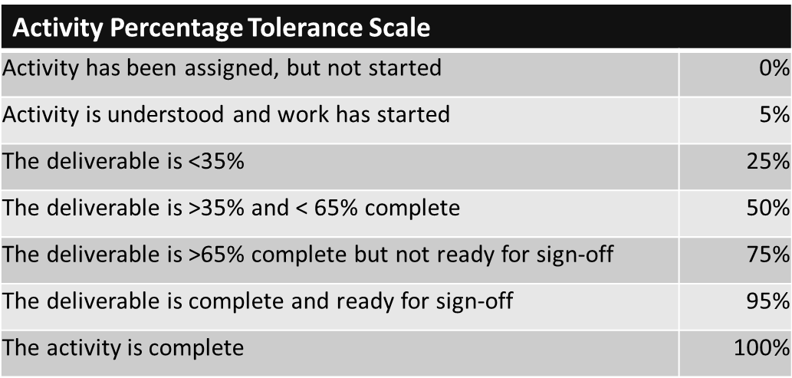

Action and Issue Management Plan
The Action and Issue Management Plan document outlines the detail and management of the plan. The document outlines the steps that the Program Manager will initiate to manage all Program issues and corresponding actions.

Risk Management Plan
Please refer to the Risk Management Plan document which outlines the details of how risk will be managed for this Program.

Cost Management Plan
Cost Management is the responsibility of the Program Manager, based on the Program cost budget approved in the Program Charter (as adjusted by any approved Program Change Requests). The Program Manager will manage accounting for cost deviations and presenting the Program Owners and/or Executive Sponsors with Program cost updates at an appropriate frequency (minimum is monthly) throughout the duration of the Program.

If appropriate, the Program Manager will also review with Program team members the Program cost totals as accumulated. Program costs must be recorded in accordance with CWB Finance and Accounting Policies, including Policy – 01 Internally Generated Assets: Computer Software and Applications. Additionally, all Programs forecasted and actual costs will be tracked in ServiceNow PPM.

In the event that total cost estimates increase beyond that approved in the Program Charter or new agreed baseline, approval of a Change Request will be required pursuant to the Program Change Control Process.

Resource Management Plan
Resource Management is the responsibility of the Program Manager and Program Owner. A description of the Program team structure can be found in the Program Charter. The resource forecast for the Program will be tracked in ServiceNow PPM. The resource forecast for each role required for the Program will be entered by the Program Manager (or delegate) during the Initiation stage of the Program and will be updated with assigned resources during the Planning stage. Any changes to the resource forecast will be maintained by the Program Manager (or delegate) throughout the Program.

Communications Management Plan
Program Communications Management is the responsibility of the Program Manager, and involves ensuring timely and appropriate generation, collection, distribution, storage, retrieval and ultimate disposition of Program information. See the Program Communications Framework document, which will serve as a guide for communications throughout the life of the Program and will be updated as communication needs change.
The Program Communications Framework guides what information to communicate, who is to do the communicating, when to communicate it and to whom to communicate. The framework outlines the recommended communications methods including meetings and status reporting for the Program. It also includes the tolerance scale to be used for Program status reporting.

Program Stakeholder Management Plan
The Program team will create and maintain a Program Stakeholder Management Plan that identifies the key Stakeholders that are either directly impacted or will be engaged as part of the Program. The list of stakeholders has been identified in the Program Charter. This plan will be developed by the Program Manager, as well as reviewed by the Program Owners to ensure completeness of the Stakeholder identification and engagement strategy defined.

Program Quality Plan
The purpose of the Program Quality Plan is to manage the quality within the Program. The plan identifies the Program quality metrics that will be tracked, reported, and analysed throughout the Program implementation.

Program Change Control Plan
Control of change means the assessment of the impact of potential changes, their importance, costs, and judgmental decisions by management on whether to include them or not in the Program. The purpose of the Program Change Control Plan is to set out the methods and procedures to handle all changes and impacts affecting the Program scope, which includes:
- Resources, costs, and timing.
- Scope, benefits, deliverables, products, and process quality.
Refer to the Program Change Control Plan for additional details on how the Program will manage change.

Approval Management Process
This Program will follow the Deliverable Approval Management Process defined for the Program.

